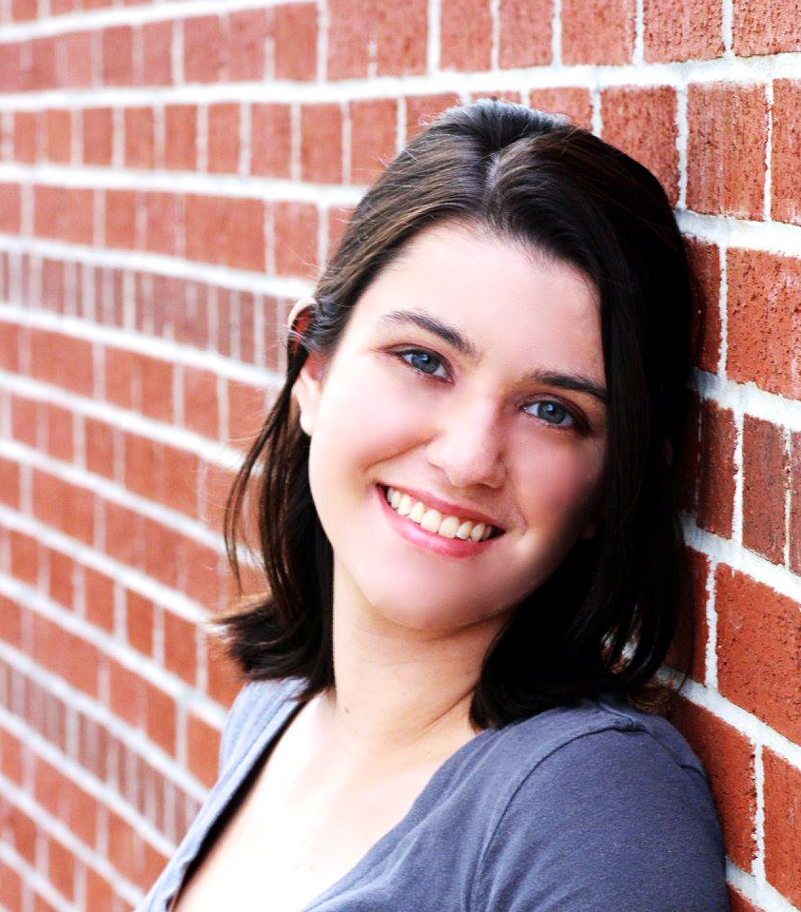 |  | MELISSA DUNN
Profile  Experienced Coordinator with a demonstrated history of working in both education and the entertainment industry. Career goals include growing as a theatre professional and working towards becoming a skilled leader in the arts and entertainment community.  Contact  PHONE:  352-216-9884  WEBSITE:  www.MelissaDunnFL.com  EMAIL:  Melissa.Ordeneaux@gmail.com  Skills  - Microsoft Office  - Google Docs  - Vocalist  - Actor  - Customer Service  - Communication and Organization |  | WORK EXPERIENCE  St. Petersburg City Theatre Teaching Artist  July 2020- Present  Lead Saturday workshops for student performers ages 7-14. Direct youth production (ea. Annie Jr, Getting to Know Rogers and Hammerstein’s Cinderella, Pirates of Penzance Jr.).  Odd-o-t’s Entertainment Performer  October 2020  Scare Actor for “Creatures of the Night” at Zoo Tampa at Lowry Park.  Florida State Fair Authority Entertainment Coordinator  February 2020, March-May 2021  Stage Manager for the Community Stage. Communicated with scheduled performers, including dance teams, solo artists, bands, and show choirs. Coordinated necessary details and information between sound technician, lighting technician, parking attendants, front of house, and guests. Maintained organization and cleanliness of stage. Made decisions and executed last minute changes as needed.  Country Day School Music and Performing Arts Teacher  May 2017– December 2019  Educated students 1-6 years in old in Music and assisted with Theatre classes for students in 1st through 8th grade. Offered additional support in many various areas throughout the school.  Universal Orlando Resort ASM/ Entertainment Coordinator  August 2016 – May 2017  Served on various teams for Marquee events, including Halloween Horror Nights, Grinchmas, and Mardi Gras. Responsibilities included supervising performers, maintaining quality of show elements, and interacting with guests as needed.  EDUCATION  Florida State University  2012 - 2016  BA Theatre; Minor in Education

